Project Report

1. INTRODUCTION

1.1 Project Overview
EduGenie is an AI-powered educational learning assistant designed to help students, educators, and self-learners access intelligent educational support through a single web platform. The application integrates multiple AI-driven learning features, including Question Answering, Concept Explanation, Quiz Generation, Text Summarization, and Personalized Learning Path Recommendations. By leveraging Google Gemini AI and a lightweight local language model (LaMini-Flan-T5), EduGenie provides fast, accurate, and interactive educational assistance. The platform is developed using FastAPI, Python, HTML, CSS, and JavaScript with a modular architecture that ensures scalability and maintainability.

1.2 Purpose
The primary purpose of EduGenie is to simplify the learning process by providing personalized AI-powered educational assistance. Instead of using multiple websites and learning platforms, users can access all major educational services through a single application. The platform aims to improve conceptual understanding, reduce learning time, encourage self-assessment through quizzes, and provide structured learning paths for continuous skill development.

2. IDEATION PHASE

2.1 Problem Statement
Students often spend significant time searching for educational resources, understanding difficult concepts, preparing quizzes, summarizing lengthy content, and planning what to learn next. Existing educational platforms generally focus on only one feature, requiring learners to switch between multiple applications. EduGenie solves this problem by integrating multiple AI-powered educational services into one intelligent learning platform.

2.2 Empathy Map Canvas
The empathy map was created to understand the needs, challenges, goals, and expectations of students and self-learners. It identified common pain points such as information overload, lack of personalized guidance, inefficient revision methods, and fragmented learning resources. These insights guided the design and feature selection of EduGenie.

2.3 Brainstorming
Several educational solution ideas were discussed, including AI tutoring, automated note generation, quiz creation, learning path recommendation, concept explanation, multilingual learning, and voice-based interaction. After evaluating feasibility and user needs, the team selected EduGenie as an integrated AI learning assistant combining the most valuable educational features into a single platform.

3. REQUIREMENT ANALYSIS

3.1 Customer Journey Map
The customer journey begins when a learner accesses EduGenie and selects an educational feature such as Question Answering, Concept Explanation, Quiz Generation, Summarization, or Learning Path Recommendation. The user enters the required input, the backend processes the request using AI models, and the generated response is displayed instantly. The learner can continue exploring additional educational tools within the same platform.

3.2 Solution Requirements

Functional Requirements
- AI-powered Question Answering
- Simplified Concept Explanation
- Quiz Generation
- Educational Text Summarization
- Personalized Learning Path Recommendation
- Responsive Web Interface
- FastAPI Backend Integration

Non-Functional Requirements
- User-friendly interface
- Secure API key management
- High system reliability
- Fast response time
- Modular architecture
- Future scalability

3.3 Data Flow Diagram
The Data Flow Diagram illustrates the interaction between users, the web interface, FastAPI backend, AI modules, Google Gemini API, and the local explanation model. Educational requests flow through the backend, are processed by the appropriate AI service, and the generated responses are returned to the user.

3.4 Technology Stack
Layer | Technology
Frontend | HTML5, CSS3, JavaScript
Backend | FastAPI, Python
AI Services | Google Gemini API
Local AI Model | LaMini-Flan-T5
API Server | Uvicorn
Deployment | Render
Version Control | Git & GitHub

4. PROJECT DESIGN

4.1 Problem Solution Fit
EduGenie directly addresses the challenges faced by students by combining multiple educational AI services into one application. The platform minimizes learning effort, provides instant responses, encourages self-assessment, and supports structured learning without requiring users to switch between multiple tools.

4.2 Proposed Solution
EduGenie is a centralized AI-powered educational assistant capable of answering questions, explaining concepts, generating quizzes, summarizing educational content, and recommending personalized learning paths. The application integrates cloud-based AI services with a lightweight local language model to balance performance, cost, and scalability.

4.3 Solution Architecture
The architecture consists of a responsive web interface connected to a FastAPI backend. The backend routes user requests to appropriate AI modules, including Google Gemini for educational content generation and LaMini-Flan-T5 for local concept explanation. The generated responses are processed and returned to the frontend for display.

5. PROJECT PLANNING & SCHEDULING

5.1 Project Planning
The project was executed using Agile methodology and divided into three sprints.
- Sprint 1: Project setup, FastAPI backend, Google Gemini integration, Question Answering, Concept Explanation.
- Sprint 2: Quiz Generation, Summarization, Learning Path Recommendation, API integration.
- Sprint 3: Frontend development, deployment, testing, optimization, documentation.

6. FUNCTIONAL AND PERFORMANCE TESTING

6.1 Performance Testing
The application was tested to validate functionality, response accuracy, and performance.
Testing included:
- Educational question validation
- AI response generation
- Quiz generation
- Summarization
- Learning path generation
- API connectivity
- Response time evaluation
- User interface responsiveness
All major functional test cases passed successfully.

7. RESULTS

7.1 Output Screenshots
1.home
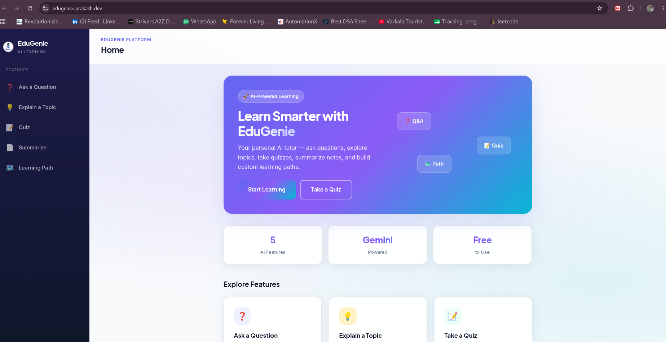

2.Ask a question
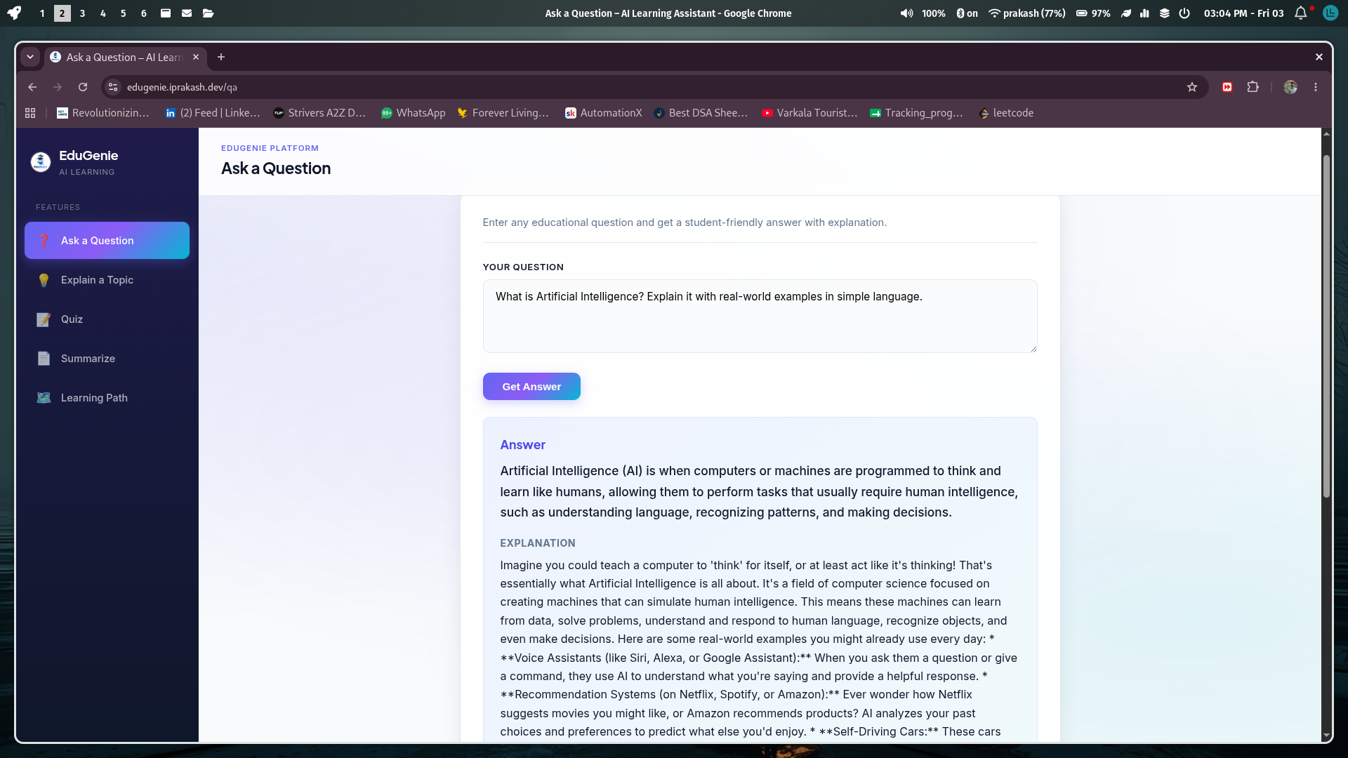
3.explain a topic
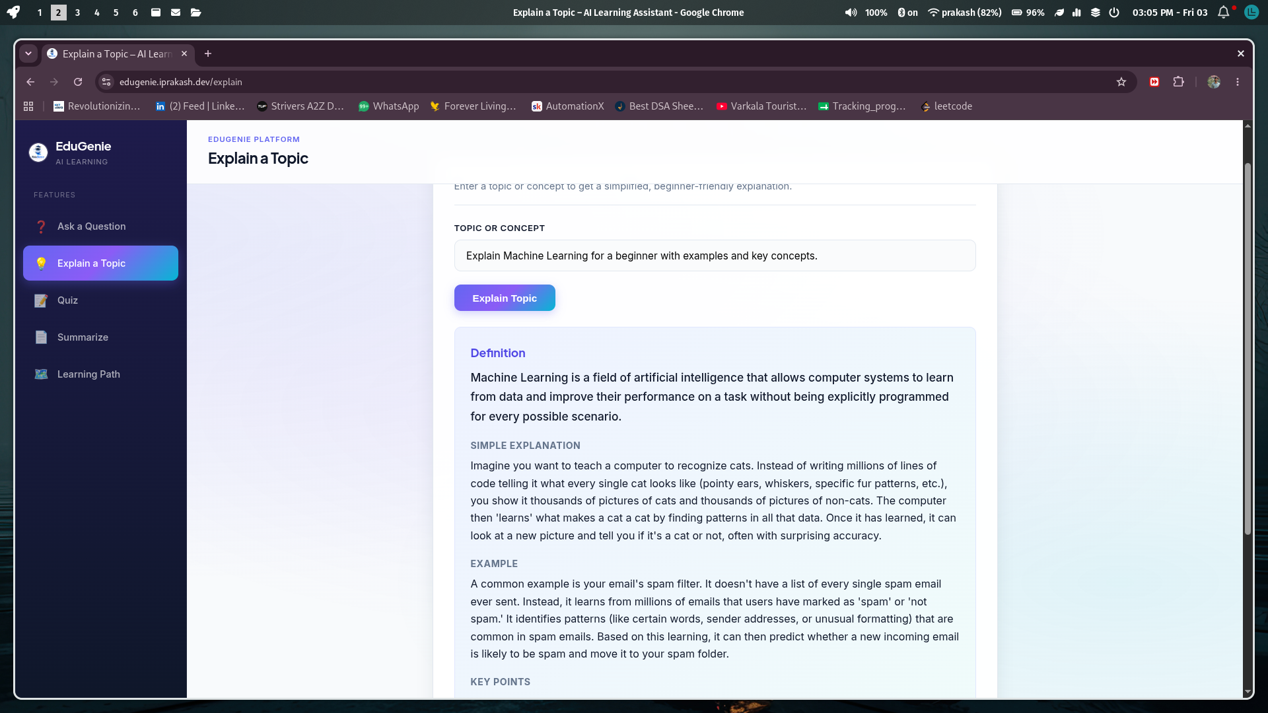

4.quiz

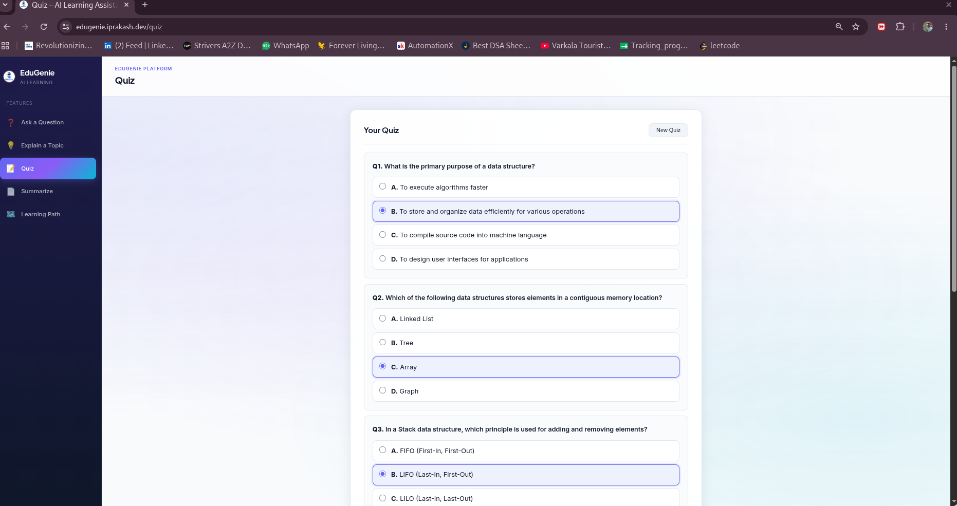

5.summarize
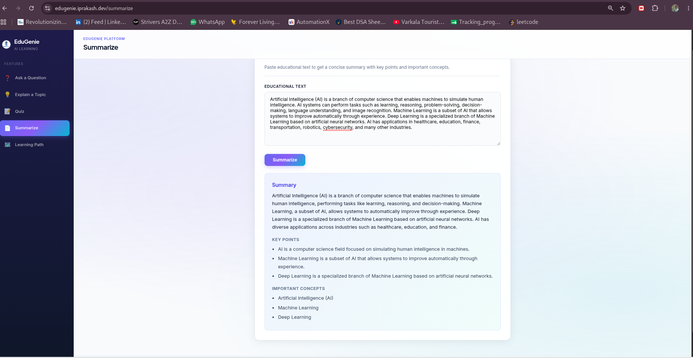
6.learning path
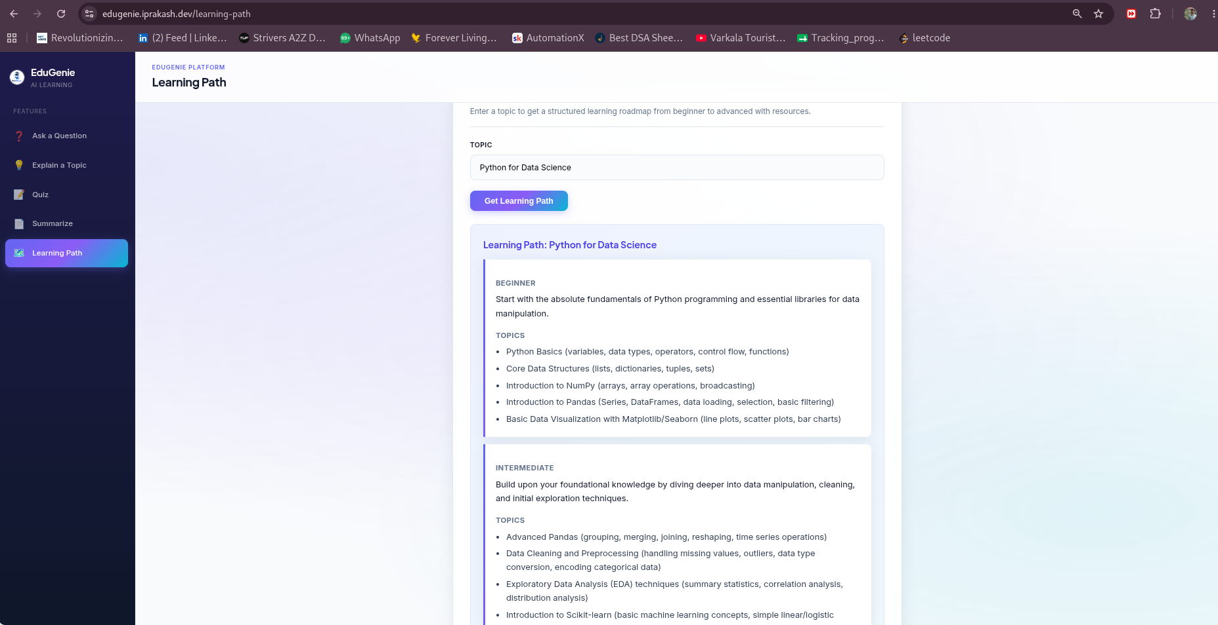

8. ADVANTAGES & DISADVANTAGES

Advantages
- AI-powered educational assistance
- Integrated learning platform
- Personalized learning support
- Fast and interactive responses
- Responsive web interface
- Easy to use
- Modular architecture
- Scalable design

Disadvantages
- Requires internet connectivity for cloud AI features.
- AI-generated responses depend on external API availability.
- No user authentication or progress tracking in the current version.
- Some advanced features require API usage limits to be considered.

9. CONCLUSION
EduGenie demonstrates how Artificial Intelligence can simplify and personalize the learning experience by integrating multiple educational services into one intelligent platform. Through Google Gemini AI, FastAPI, and a modular architecture, the application provides accurate educational assistance, supports self-learning, and promotes efficient knowledge acquisition. The project highlights the practical application of modern AI technologies in education while maintaining scalability and ease of use.

10. FUTURE SCOPE
Future enhancements include:
- Voice-based interaction
- Multilingual educational support
- User authentication
- Learning history
- Progress tracking dashboard
- AI chat memory
- Mobile application
- LMS integration
- Collaborative learning
- Cloud auto-scaling
- Advanced analytics
- Offline educational mode

11. APPENDIX

GitHub & Project Demo Link
- GitHub Repository: https://github.com/prakash-2736/Edugenie
- Live Demo: https://edugenie.iprakash.dev

